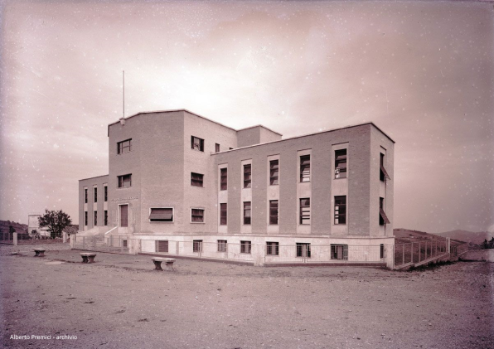
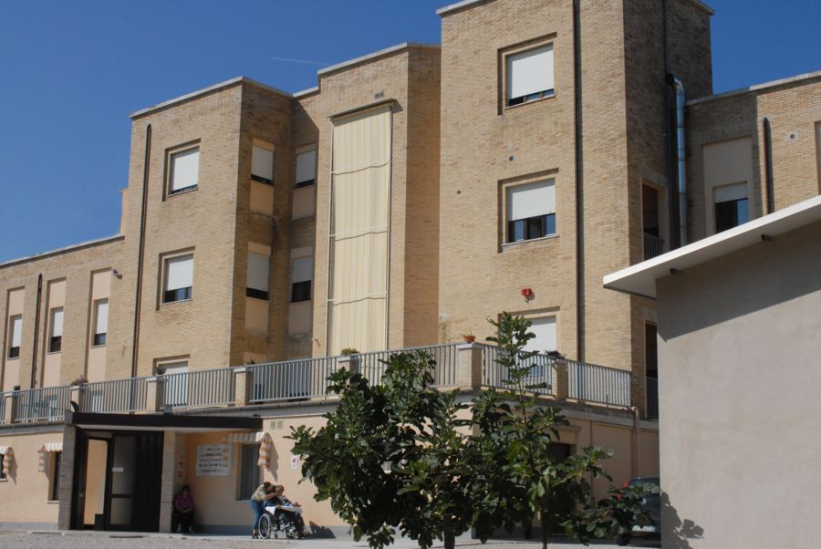

SERVICES CARD

Opera Pia Bergalucci Psycho-Pedagogical Medical Institute

Borgo Cappuccini n. 33
63073 OFFIDA (AP)

Tel./Fax: 0736889341
Mail: istituto.bergalucci@libero.it

 | Indice | pag
 | The Bergalucci Institute | 3
 | - Birth and history | 3
 | - Yesterday and today | 3
 | Services hours and working professionals | 4
 | Guide to performance and services | 5
 | Commitments and programs for quality of service | 7
 | Admission and resignation | 7
 | Quality indicators | 8
 | Relations with associations | 8
 | User protection | 9
 | - Rights and duties of users | 9
 | - Rules of community life | 10
 | Division of health facilities within the institution | 11
 | - Rsa for psycho-physical disabled people | 11
 | - Protected residence for the disabled | 12
 | - Protected residence for the elderly | 12
 | - Nursing home for the elderly | 12
 | Terms of payment | 13
 | Insurance policies | 13
 | Where to find us | 13
 | Accomodation opening hours | 14
 | - Hours of the u.r.p. | 14

THE BERGALUCCI INSTITUTE

BIRTH AND HYSTORY

The birth of the Institute called "OPERA PIA BERGALUCCI" dates back to 18 December 1913 when Vittorio Emanuele III, King of Italy, recognized as a moral body the pious foundation established in Offida with a will dated 13 September 1862 by Don Giovanni Bergalucci.
In the organic Statute of the Opera Pia Bergalucci, made up of 38 articles and signed on 03 November 1913, it was established that the purpose of the institution was to "GUARANTEE ASSISTANCE TO ORPHANS AND THE ELDERLY OF THE MUNICIPALITY OF OFFIDA". The activity envisaged by the Statute has since then been carried out regularly without interruptions or news of evident changes in the purpose pursued by the institution, with the natural succession of the Boards of Directors and the various Presidents and Directors.
At the beginning of the 1970s the councilors recognized the first need for a modification of the goal pursued by Bergalucci. In 1970 the Board of Directors decided to expand the assistance activity of the Opera Pia Bergalucci, and the following year a Psycho-Pedagogical Medical Institute was created within the Bergalucci institution. After some economic and managerial difficulties, the Institute resumed regular activity from the end of the 1990s. All this was made possible by administrative efforts aimed at rationalizing resources, strengthening personnel and relaunching the business.

YESTERDAY AND TODAY

Since 1995, the Institute has been able to benefit from a Memorandum of Understanding with the General Managers of the Local Health Units falling within the territorial area of ​​the province of Ascoli Piceno, created in order to ensure adequate health care for people with severe disabilities psycho-physical present in the structure. Since 1997, the Board of Directors has signed agreements with the Healthcare Companies operating within the Marche region (1997 Fermo, 2000 Ascoli Piceno and San Benedetto del Tronto, 2002 Macerata, 2006 Civitanova Marche). Thanks to the opportunities offered by the L.R. no. 20/2000 and no. 20/2002, the institute reorganized its activity by starting the creation of new health and social-health structures, aimed at adult guests, within the psycho-pedagogical medical institute, for which an impressive process was carried out restructuring and modernization of the headquarters building, the existing services were strengthened and new ones created with the introduction of numerous professional figures to complete the educational-rehabilitative path which is the basis of the institute's activity.

SERVICE HOURS AND OPERATING PROFESSIONALS

The professional figures who allow the institution to guarantee its guests nursing care and care and assistance activities for the entire twenty-four hour period, 365 days a year, are engaged in the various activities based on the following organization:
- n. 5 Social Health Operators;
- a Social Health Operator guarantees assistance even during the night hours (10:00 pm – 8:00 am);
- the presence of one or two professional nurses is always guaranteed within 24 hours;
- on Tuesdays and Wednesdays, GPs and specialist doctors are present;
- the figure of a professional educator or animator is also guaranteed, from 9:00-13:00 - 15:00-19:00 depending on the programmed interventions;
- a psychiatrist and a physiotherapist collaborate with the Institute to better protect the psycho-physical health of the guests.
The professional figures indicated are supported, as regards the planning of interventions, by a nursing coordinator, a psychologist-coordinator and a
social worker, who complete the multidisciplinary team.
The monitoring of the progress of all the services aimed at each individual guest is guaranteed by the use of the ABC-Web system, which allows all the operators involved to record information regarding guests on a daily basis.
All personnel are required to update and undergo periodic training, established in the "Annual Training Plan" and monitored by the Training Manager.
The administrative management and the structure coordinator are constantly present to ensure constant supervision of the correct performance of the work, in compliance with the professional ethics of all the figures involved.
Within the organization chart there are figures of responsibility, each of which performs a strategic function:
- Institute manager: deals with the coordination and hierarchical management, as well as with the administrative activities of the personnel belonging to the nursing and social health area. He is also responsible for the management of complex internal organizational relations as well as external relations, on the basis of the organizational provisions of the Body. The position is currently held by Dr. Bruno Fioravanti, present in the structure for 3 days a week (Monday, Wednesday and Friday), from 9:00 to 12:00.
- Administrative Manager: supervises, organizes and coordinates the administrative, accounting and financial services of the company. It ensures the accounting treatment of economic, patrimonial and financial transactions based on current legislation and supervises the preparation of the financial statements.
- Maintenance manager: performs the function of planning, coordinating and controlling the execution of repair, maintenance and improvement works on plants, machinery, equipment and appliances. He supervises the assigned personnel by observing the general and specific safety rules and measures.
- Quality manager: is responsible for coordinating and managing the quality control activities of the services offered by the Institute. He therefore verifies that the performance of the duties complies with the pre-established standards.
- Training manager: defines the policy and implements the general training objectives, supporting the Management in defining the corporate training plan.

GUIDE TO PERFORMANCES AND SERVICES

Numerous services are provided daily within the Institute, aimed at pursuing the objectives of the individual PAIs and protecting the psycho-physical health of adult patients. As part of the education-entertainment activities, the following are offered:
- practical and creative activities in the laboratory;
- cognitive stimulation;
- organization of parties and events (Christmas, Easter, representations on the occasion of the Carnival, preparation of decorations and festoons, ...);
- help in carrying out some daily services (preparing the table for lunch and dinner, arranging rooms and personal wardrobes, ...);
- cooking activities and preparation of simple culinary recipes;
- outings with operators (days at the beach, in the mountains and in parks, visits to sanctuaries in the area, days on the boat, ...);
- participation in special community events (village festivals, weekly market, etc…);
- participation in recreational events (cinema, theatre, entertainment shows, ...);
- participation in events with the presence of family members, friends and volunteers (San Martino party, Christmas party, Carnival party, annual Spring party, weekly stay with overnight stay in summer, annual trip to Loreto, ...);
- motor activity in the gym inside the institute;
- basic physical rehabilitation activities on site;
- periodic meetings with operators and patients from other facilities and similar rehabilitation centers for socialization and reciprocal exchange of experiences.
These activities take into account the international guidelines on the subject of diagnosis and treatment of patients with psycho-physical disabilities (International Classification of Functioning, Disability and Health. WHO, 2020). In particular, the team of the soul-educational department uses basic techniques of the behavioral method (Foxx, 1995; Zanobini and Usai, 2019; Cottini et al. 2018).

As regards the health aspects:
- pharmacological therapy is monitored by professional nurses and general practitioners, in agreement with the medical director of the facility;
- weekly the general practitioner checks the general state of health of the patient with the prescription of any specialist diagnostic test that may become necessary;
- the administration of drugs is always carried out by professional nurses;
- periodically, at the request of the institutions (for example DSM or UMEA) or of the ADS, updated reports on the psycho-physical health of the guests are drawn up and sent to the applicant. In this way, communication and "networking" between all the subjects involved in the patient care project are encouraged;

With reference to the family aspect and the patient's reintegration into the family, it should be emphasized that:
- especially in the first phase of the patient's entry, a greater presence of the family member in the structure is allowed, to try to make the emotional detachment from the family of origin gradual and as less traumatic as possible;
- the family member is always guaranteed the opportunity to visit the guest, by appointment, to avoid gatherings and excessive confusion. In case of need and special events, the times can be modified with authorization, providing for the possibility for family members to be welcomed into the structure throughout the 24 hours;
- where possible, the patient's temporary return home is encouraged and managed, also with the collaboration of staff and volunteers at the patient's home;
- booking - transport and assistance in cases of specialist visits to be carried out at specialized clinics or hospitals (in collaboration with family members);
- search for qualified personnel in cases of hospitalisation;
- the family is involved and kept informed of every decision (medical or otherwise) concerning the patient; through periodic communications from the management, the family member is kept informed of the activities organized by the Institute for its guests and invited, where possible, to participate;
As far as the hotel aspects are concerned, the structure offers its guests:
- internal canteen service with the possibility of choosing between different menus in compliance with the diets established by the doctor in charge for each patient, taking into account the nutritional and dietary needs or different diets;
- hairdresser - barber - pedicure and manicure services (according to requests and needs);
- laundry service and internal cloakroom management;
- large garden and outdoor gazebo.

COMMITMENTS AND PROGRAMS FOR QUALITY OF SERVICE

In the three-year period 2022/2024, the Company Management, in order to improve the quality of the service for users, undertakes to:
- provide all health, psychological and social assistance services aimed at achieving the PAI;
- renew the authorization to operate pursuant to the new DGR 1571/2019;
- obtain regional accreditation pursuant to DGR 1572/2019;
- invest in the training of all personnel;
- insert the structure in a prevention system to which citizens can refer;
- adopt practices and documents to guarantee assistance to those with particular linguistic/ethnic specificities or physical difficulties (Humanisation);
- monitor the state of the structure and the updates of the technologies currently in place and then consider a change/replacement;

ADMISSION AND RESIGNATION

The request for admission to the structure can be formulated:
• From the UMEA or from the DSM of the Health Authorities of residence;
• by the Social Services of the Municipality of residence;
• by the general practitioner;
• by the user or by family members
and must necessarily be accompanied by a detailed report on the pathologies, behavioral problems, pharmacological therapies, pathological history. Based on this information, the request is subjected to a medical assessment by the Institute's multidisciplinary team.
In the event of a positive evaluation of the application, if there is availability of beds, the applicant is contacted to start the procedures necessary for insertion (authorisation of the Health Authority / Municipality of residence, determination of expenditure commitment, etc.). If there are no places available, after informing the applicant of the positive admission assessment, it will be included in a Waiting List that will take into account the social, health and environmental characteristics of the request, organized according to chronological criteria and updated at least annually in its composition according to the persistence of the insertion needs of the applicants for admission. Any modification and updating of the Waiting List is motivated by a written report. The Waiting List can be examined by the contact persons of the subjects requesting admission, always in compliance with the legislation on privacy. As soon as a place becomes available in the Institute, the applicant whose application for placement is still valid and has been pending the longest will be contacted.
The definitive insertion of the user is subject to passing an initial trial period of one month, following which the definitive insertion can be carried out. Subsequently, the PAI will be drawn up and re-evaluated during the stay in the institute, on a six-monthly or annual basis.
The request for resignation can be formulated by the admission applicants themselves and is subject to a notice period of 1 month.
The resignation will be ratified by a letter from the Medical Director to which a technical report of the facility team will be attached, in which reference will be made to the patient's state of health, the therapy followed, the objectives achieved (and not) and a copy of the medical record and, when required, the PEP accompanied by all the periodic verification forms.

QUALITY INDICATORS

The Bergalucci Institute has always attributed the utmost importance to the quality of the service offered to its guests, therefore three-year and annual improvement plans are drawn up. Their application allows effective control of the quality standards achieved by the Institute and control of the general growth trend of the structure. For users and family members, the quality orientation assumed by the Institute will be visible thanks to the following qualitative evaluation parameters:
- degree of achievement of the objectives established in the PAI and subsequent re-evaluations;
- average daily number of assistance minutes per user;
- evaluation of user satisfaction for the aspects: educational, welfare, hotel, medical-health, relational and quality of life in the structure;
- structural and instrumental improvements and modernisations;
- number and quality of educational and recreational activities, as well as the participation of users in them;
- monitoring and management of non-conformities and adverse events;
- incident reporting;
- safety walk around;
- periodic monitoring of the corporate climate.

RELATIONS WITH ASSOCIATIONS

As regards the Institute's relations with the social reality of the territory and the voluntary associations for the purpose of enriching the offer of services in favor of users, there are:
- Relations with the AVULSS association for assistance in health facilities;
- Relations with the Offida and San Benedetto del Tronto sections of UNITALSI in order to guarantee assistance during exceptional events;
- Collaboration with the Croce Verde section of Offida for the transport of disabled people with exceptionally serious motor problems;
- Collaboration with the association LAV (Letture ad Alta Voce) of Ascoli Piceno;

USER PROTECTION

The protection of guests' rights and privacy is complied with by Legislative Decree 101/2018 and GDPR 679/2016.
To remove any situations that limit the possibility of using the services offered in the structure, users can file a complaint. The purpose of the complaint is to offer users an agile and immediate tool to report to the Management situations that are not in line with the principles, commitments and purposes expressed in this Charter. It is envisaged that the user of the structure is protected by a special body, the Committee of Family Members, to which he can refer for the resolution of problems. The Committee, chaired by the lawyer Alfredina Grelli, is automatically informed of the presentation of the complaint.
How to present the complaint:
complaints can be expressed in form by filling in a special form "5.5.1-MOD Complaint-report form" and delivered to the management, on paper or by email, at the address: istituto.bergalucci@libero.it.
Alternatively, complaints can be sent by regular mail to:
OPERA PIA BERGALUCCI, Borgo Cappuccini n° 33, 63037 OFFIDA (AP)
Anonymous complaints are not taken into consideration unless duly substantiated.
The Bergalucci Institute, through its U.R.P. or the quality manager, after having carried out all possible investigations on the matter, responds, always promptly and, in any case, no later than thirty days, taking steps to remove the causes that gave rise to the complaint.

RIGHTS AND DUTIES OF USERS:

The user has the right:
- participation in the various activities proposed according to one's personal preferences and abilities;
- to be safeguarded and protected in case of emergency or danger by the staff of the Institute;
- to have the security of their personal data guaranteed, which can be used and processed exclusively for the purposes of managing and operating the service;
- the guarantee that the socio-educational and assistance activity provided complies with the quality and conditions indicated in this service charter;
- the right to information is guaranteed.
The user and his family have the duty to:
- respect the correct execution of the tasks of the personnel in service;
- promptly inform the heads of the Institute of the intention to give up, according to one's own decision, scheduled activities and services;
- collaborate in order to allow the educational project and the activities carried out to be developed in the best possible way;
- respect the organization and rules of community life of the Institute, such as:
- for users: respect the times established for the administration of medicines and meals; comply with basic sanitation standards; avoid aggressive and offensive attitudes towards other guests or operators; respect the rules established by the staff during exits outside the institution;
- for family members: respect the procedures for booking visits, established periodically by the health management; deliver any food or gifts as a gift to the staff of the educational department.

Rules of community life:

Guests are ensured a normal life of relationships based on their various propensities and desires, also organizing the activities in such a way as to allow, within the structural limits, the preparation of the best possible relational conditions, making the person the protagonist of their day.
The guest undertakes to:
- Observe the rules of hygiene of the environment and of the person, according to the prescriptions and the possibly prepared calendar;
- Maintain the accommodation and common areas, structures, furnishings and systems installed therein in good condition.
- Allow the service personnel or any other person appointed by the Organization to access the accommodation to carry out cleaning, checks and repairs;
- Use decent and decent clothing;
- Respect the normal rules of coexistence and any other rule that the institution will issue and which will be appropriately brought to the attention of the guests.
- It is forbidden for guests to bring alcoholic beverages and drugs, animals and electrical appliances for heating including electric blankets, stoves and irons into the facility.
- The Organization will take care of the custody of the assets and sums of money entrusted to it by the assisted persons or their families, issuing a specific deposit receipt.
- On the other hand, the institution declines any responsibility for the values ​​in goods and money personally kept in the rooms by the guests.
- In the event of the guests' death, the objects and sums of money kept may be withdrawn by the legitimate heirs, ascertained by means of adequate documentation, subject to the settlement of any guest's debt towards the structure.

DIVISION OF THE HEALTHCARE STRUCTURES WITHIN THE INSTITUTE

The following types of health and social health facilities have been created within the Institute:

• Health Care Residence (R.S.A.) for the psycho-physically disabled;
• Protected Residence for the disabled;
• Protected Residence for the Elderly;
• Rest home for the elderly.

RSA FOR PSYCHO-PHYSICAL DISABLED

The RSA for the psycho-physically disabled is a residential facility that deals with the care and assistance of psycho-physically disabled people. It has a total of 20 beds.

PURPOSE AND GENERAL OBJECTIVES

The Healthcare Residence For Disabled is configured as a specially structured and suitable space to protect the health and encourage the process of growth and social integration of temporarily or permanently disabled people, providing individualized intervention programs to develop and/or improve the skills and skills needed to achieve these goals.
In pursuing its mission, the choice of structure was to conform to a community and family-based rehabilitation model, focused on the care of individual and group interpersonal relationships.

PROTECTED RESIDENCE FOR THE DISABLED PEOPLE

The Protected Residence for the disabled is a social-health and social-welfare structure, intended for people with disabilities who lack the necessary family support, or for whom staying in their family nucleus is no longer considered possible.
It has a total of 18 bed places.

PURPOSE AND GENERAL OBJECTIVES
This type of structure is characterized by a global approach to the needs of the guest, guaranteed by a multidisciplinary team and by the definition of an Individual Project, shared with the family. The system of services provides each guest with the answers to his rehabilitation, educational, care, socialization and social integration needs.
In the Protected Residence for the Disabled, the global approach to the needs of the guest is centered primarily on personal care, on the development or maintenance of primary autonomy and on the development of interests and skills in the various areas.

PROTECTED RESIDENCE FOR THE ELDERLY

The Protected Residence for the elderly is a residential structure with a high level of socio-medical integration, intended to permanently accommodate non self-sufficient elderly people with outcomes of stabilized physical, mental, sensory or mixed pathologies, difficult to treat at home and who do not require services complex healthcare.
The R.P. for the elderly it has a total of 4 beds.

PURPOSE AND GENERAL OBJECTIVES

The main objective is to provide hospitality and a good quality of life, ensuring an average level of medical, nursing and rehabilitation assistance and a high level of guardianship and hotel assistance.
The purposes inherent in maintaining and improving the state of health and well-being of the elderly hosted, are pursued through opportunities for community life, recreational activities and services to help in daily activities, as well as activities aimed at maintaining and activating residual capacities (medical, nursing and rehabilitation assistance).

NURSING HOME FOR THE ELDERLY PEOPLE

It is a residence for self-sufficient or partially self-sufficient elderly people, where it is possible to receive nursing and social-health assistance, in order to be able to share time with people who are in the same condition.
The Rest Home of our Institute has a total of 4 beds.

PURPOSE AND GENERAL OBJECTIVES

The main aim pursued is to guarantee socio-medical assistance to the guest, within a climate that favors socialization.
To this end, the presence of socio-medical, nursing and mental-educational personnel is foreseen.
In addition to the welfare aspects, particular attention is paid to the organization of recreational, recreational or cultural activities, such as reading groups, excursions in the area, parties and cognitive or motor stimulation activities.

TERMS OF PAYMENT

Fees are paid by bank transfer. All specific information is referred to guests (or family members/Ads) upon entering the facility.

INSURANCE POLICIES

Every year the Istituto Opera Pia Bergalucci stipulates a regular insurance coverage policy for civil liability towards third parties with Generali Italia S.p.a.

WHERE TO FIND US

The “OPERA PIA BERGALUCCI” Medical Psychological Pedagogical Institute is in Offida, a medieval village of about five thousand inhabitants in the province of Ascoli Piceno, located among the verdant Ascoli hills a few kilometers from the sea.
The building is structured on four floors, the ground floor houses the general services and spaces for the realization of educational and recreational-recreational activities (concierge, secretarial office, administrative management, health management, multipurpose room, waiting room, chapel, Kitchen, Gymnasium and Physiotherapy room), the other three house the hospital wards and refectories connected to each other and to the general services floor by means of an elevator and a bedlift system:
FLOOR 1:
• R.S.A. for the psycho-physically disabled;
• Protected Residence for the elderly;
• Rest home for the elderly.
FLOOR 2
• Protected Residence for the disabled.
FLOOR 3
• R.S.A. for the psycho-physically disabled.

The structure has several terraces and a large garden equipped with a gazebo, which allows for outdoor activities, such as horticultural therapy.
The Institute is located in a slightly decentralized but not peripheral area of ​​the town and can be easily reached both by car from the main communication routes and on foot, because it is very close to the bus stop that connects Offida daily with the nearby cities of Ascoli Piceno and San Benedetto del Tronto.

ACCOMMODATION OPENING HOURS:

The opening hours to the public, by appointment, are as follows:
• MORNING 10:00 – 11:30
• AFTERNOON 16:00 – 18:30.
In case of need and special events, the aforementioned times can be modified with express authorization, with the possibility for family members to be present in the structure during the 24 hours.

HOURS OF U.R.P. - HOW TO CONTACT US:

The structure has a Public Relations Office headed by Dr. Ciabattoni Lucia. The U.R.P. is able to provide all the necessary information about the services.
The U.R.P. it is present on the ground floor of the headquarters building and is open from 9:00 to 13:00, from Monday to Friday.
Please note that for requests for information of a health nature, for the release of reports or medical records, the office in charge is that of the Health Director, open to the public on Mondays and Wednesdays from 9:00 to 13:00 and Thursday afternoon from 16:00 to 19:00.
Requests for reports and health records are normally processed within the week following the request (maximum time: 15 days), providing for payment only of the cost of copying the document.

To get in touch with the Public Relations Office of the “Opera Pia Bergalucci” Medical-Psycho-Pedagogical Institute and get more information or clarifications, you can:
WRITE TO THE FOLLOWING ADDRESS:

PIA OPERA BERGALUCCI
Borgo Cappuccini n° 33
63073 OFFIDA (AP)

CONTACT US BY TELEPHONE OR SEND A FAX TO:

0736/889341

CONTACT US BY EMAIL AT THE FOLLOWING ADDRESS:

istituto.bergalucci@libero.it

